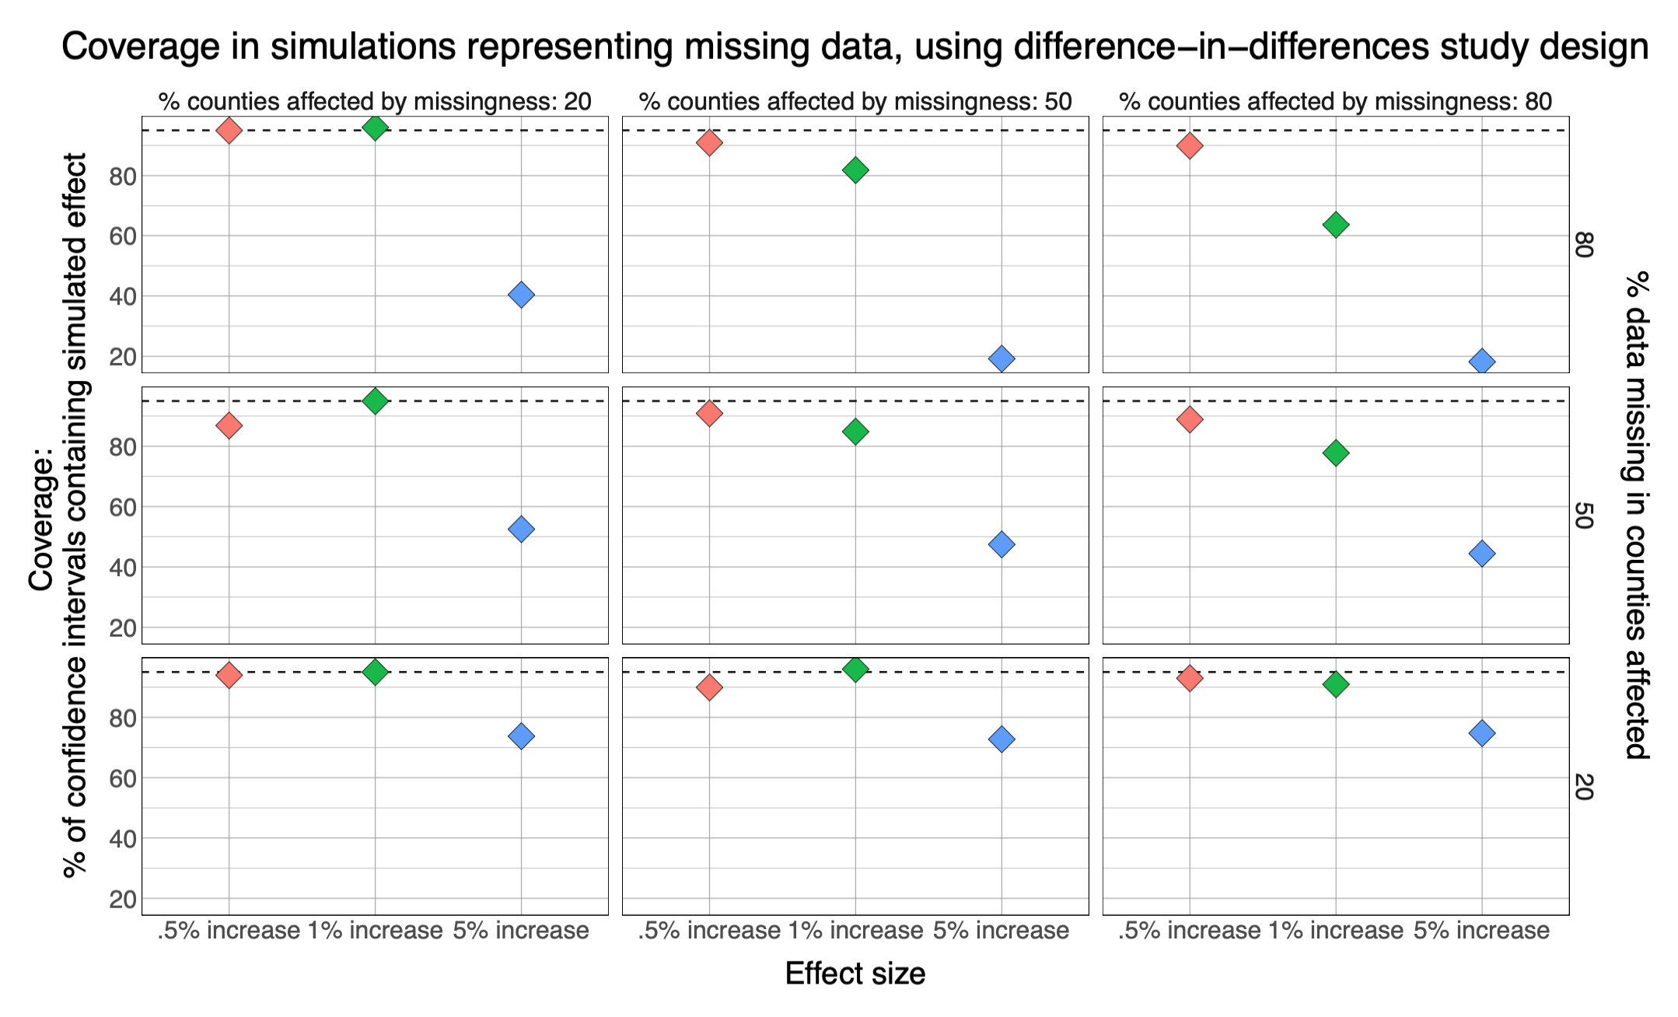

**Figure 5**: Results from simulations of the association between power outage exposure and hospitalizations in 100 counties with different percentages of exposure data missing using a difference-in-differences design. Simulations were repeated 100 times, and plots show the percent coverage of 95% confidence intervals. Results from case-crossover design are similar and are included in the supplement. There is a dashed line at 95%.